- Background: Mutual fund market practice in Indonesia capital Market
- Regulator & Government Related
  - Otoritas Jasa Keuangan (OJK), Financial Services Authority
Is governmental institution that supervise and regulate all investment activities & transaction in Indonesia Cpital Market. Investment Manager/Company, Selling Agent and Custodian Bank had obligation to regularly report, either investor profile, transaction & balance position for each product, product related information and also internal corporate information including financial data in timely manner.
  - Pusat Pelaporan & Analisa Transaksi Keuangan (PPATK), Anti Money Laundering Task Force
Is Govermental institution that montor any financial transaction for suspicious activities, money laundering or terorisme funding. Investment Manager/Company, Selling Agent and Custodian Bank had obligation to report any suspicious transaction, either adhoc request or routine reporting.
  - Direktoral Jendral Pajak, similar with IRS
Is governmental institution under ministry of finance to receive any tax payment for citizen and/or any institution that operate in Indoensia and monitor their compliances. Investment Manager/Company, Selling Agent and Custodian Bank, beside his own tax obligation, must also report his investor transaction activities, balance position to tax office, Adhoc request or routine report.
  - Bareskrim Polri, Police Criminal Justice Investigation & KPK, Anti-Corruption Commitee
Is governmental institution that had law enforcement duty. Any financial institution often requested by them to check any individual, by name or any related information that had/not any balance position and/or financial transaction through them. Either criminal suspect or public services officer or known as PEP, politically expose person.

- Process Account Opening
- Manual registration by paper form entry, complete with supporting document like copies of IDCard, Tax ID. Follow-up with face to face KYC, risk profile identification to validate & comply with desired KYC requirement.
- Electronic registration by application based entry either investor information, risk profile identification, support by authentication either for electronic ID Card, signature, face to face KYC validation and also further user access to application.
- Generate investor information (KYC), investor fund unit account and bank account comply with S-INVEST format specification than upload them into S-INVEST terminal. Review any in-completeness or in-correct data.
- KSEI S-INVEST is gateway/hub application that connect selling agent, investment management/company and custodian bank.
- Investor account can be stated as ACTIVE after receive SID (single investor identification number) from S-INVEST generator, and can be used in futher transaction.
- Process Subscription
- Manual subscription transaction is processed by form entry based contain investor information, amount of transaction and payment method description. Attached with payment proof, like ATM slip, cash slip, cheque, that can be verified into fund subscription sundry account.
- Electronic subscription transaction is processed by send similar information through electronic channel that can be automatic verified and state it as “good fund”
- Transaction received before or same as 13:00, will be processed, either manual or electronic, using same day NAV/Unit that generated at the end of day. Else will be pending and be processed at the next working business day.
- Not “good fund” transaction until 13:00 treat as same, will be pending and be processed at the next working business day.
- Subscription transaction, that state until 13:00, will be uploaded into S-INVEST system at 15:00
- Investment management/company will check all incoming subscription on their S-INVEST terminal, review & override if necessary, set selling fee then approve it
- All approve subscription will be downloaded by custodian bank then processed on their internal system for unit calculation process.
- Transaction result, unit transaction allocation that unit generated for each subscription amount, will be generated & uploaded by custodian bank into S-INVEST system at T+1 15:00
- Selling agent and investment management/company can download this data from S-INVEST terminal to be used/reconcile with their internal record, then publish it to their respected investor through application.
- Custodian bank will generate transaction report for investor, send it either hard copy via courier or e-statement into investor email.
- Selling agent and investment management/company can also download balance position for each investor, had or had not transaction, that daily uploaded by custodian bank.
- Process Redemption
- Manual redemption transaction is processed by form entry based contain investor information, amount of transaction and bank account for redemption payment. Attached with copies IDCard. Investment management/company and/or selling agent must verified his/her IDCard & signature validity.
- Electronic redemption transaction is processed by send similar information through electronic channel that can be authenticate user as valid investor.
- Transaction received before or same as 13:00, will be processed, either manual or electronic, using same day NAV/Unit that generated at the end of day. Else will be pending and be processed at the next working business day.
- Redemption transaction, that state until 13:00, will be uploaded into S-INVEST system at 15:00
- Investment management/company will check all incoming redemption on their S-INVEST terminal, review & override if necessary, set redemption fee & payment date then approve it
- All approve redemption will be downloaded by custodian bank then processed on their internal system for unit calculation process.
- Transaction result, unit transaction allocation that unit generated or amount resulted for each redemption, will be generated & uploaded by custodian bank into S-INVEST system at T+1 15:00
- Selling agent and investment management/company can download this data from S-INVEST terminal to be used/reconcile with their internal record, then publish it to their respected investor through application.
- Custodian bank will generate transaction report for investor, send it either hard copy via courier or e-statement into investor email.
- Selling agent and investment management/company can also download balance position for each investor, had or had not transaction, that daily uploaded by custodian bank.
- Selling agent can also download redemption payment instruction.
- Process Switching
- Similar process with redemption,except not redemption payment, but subscription into another mutual fund
- Note: this only apply for certain fund and custodian bank that already had agreement to process same day subscription & redemption. For others, it will treat just like normal subscription & redemption..
- Cash Dividend Distribution
- This process is cash dividend from mutual fund asset, distribute for each unit participation, transfer into each investor bank account, same with redemption payment bank account.
- This process initiate by fund manager and process by custodian bank
- Selling agent can download this information, for each investor, to be used in internal system and published to investor.
- Proses Account Maintenance: Update data bank account
- S-INVEST system only can received upload new/add bank account for investor redemption payment. There is no edit/update feature.
- Remove feature can be execute manually through S-INVEST terminal.

- Application Architecture
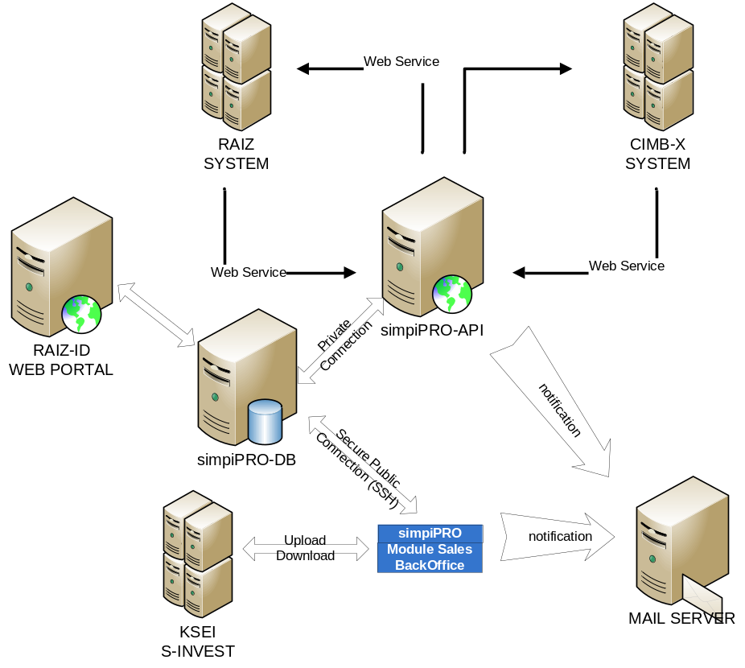
- Connection RAIZ SYSTEM with simpiPRO API: web service
- Connection CIMB-X with simpiPRO API: web service
- Any investor activity can be notify to their email, either using simpiPRO email server or client email server though simpiPRO API or simpiPRO modul Sales Back Office application.
- Connection to KSEI S-INVEST by upload & download file (format csv atau txt)
.
- Insfrastructure Architecture

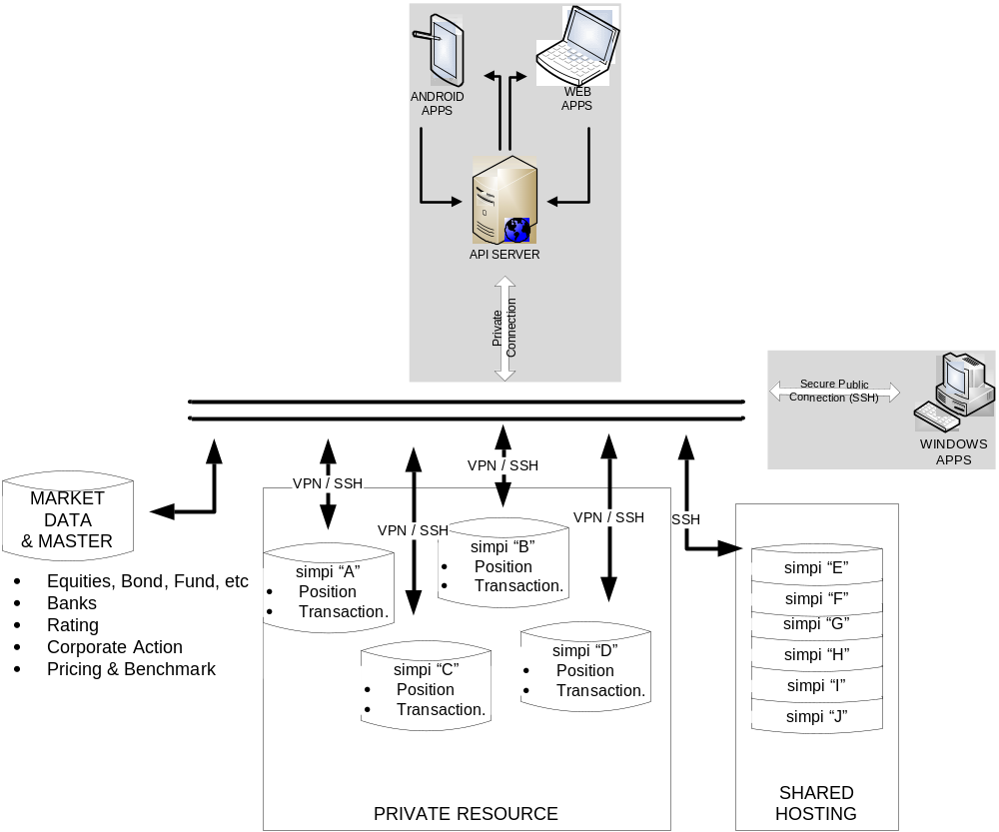

- Account Maintenance
  - Account opening/registration process
  - Input: investor information that required by S-INVEST specification
  - Output: SID (Single Identity Number) from S-INVEST Generator
  - account.individual.register
- Format: simpiPRO API
- Objective: account registration by manual processing
- Function: Receive user name, email, password and mobile number to be recorded in prospect database. Send notification to user email how to complete account registration. Either via PDF attachment or link into Raiz Web Portal. Email notification had information & instruction for user to be followup, regarding his/her account, document to be complete and how to send the overall document into Raiz Office
  - Web site portal Raiz
- This web site can be used to entry complete and required KYC information including risk profile questionary.
- User can logon into this web site using same user & password, that had been send into simpiPRO database.
- After complete & submitted, web site will send this filled PDF into email, so can be print & sign it.
- Attach with copy of IDCard, TaxID and any others required document, send into Raiz Office via courier.
- Raiz Officer, based on received document, review & compare with received document then approve investor data on application, so it can be generate & upload into S-INVEST terminal.
- Upon complete & succesfull upload, Raiz Officer then retrieve each investor SID, update it into simpiPRO to be used for futher transaction & process.

  - account.individual.new
- Format: simpiPRO API
- Objective: electronic account registration
- Function: Receive complete investor information, with mandatory field as S-INVEST requested
  - Account .individual.sid
- Format: simpiPRO API
- Objective: send investor SID information
- Function: send investor SID information based investor CIF, that had been generate by S-INVEST generator and can be used for further transaction, inquiry and data update.
  - Account .password.change
- Format: simpiPRO API
- Objective: change user password
- Function: change user password for further data access through API
  - Account .individual.login
- Format: simpiPRO API
- Objective: user login
- Function: user login using email & password, get session key that can be used for further transaction
  - Account .info.education
- Format: simpiPRO API
- Objective: send S-INVEST required field content
- Function: send S-INVEST required field for investor profile information.
  - Account .info.religion
  - Account .info.occupation
  - Account .info.incomelevel
  - Account .info.maritalstatus
  - Account .info.risklevel
  - Account .info.riskvalue
  - Account .info.riskquestioner
  - Account .info.investmentobjective
  - Account .info.sourceoffund
  - Account .info.city
  - Account .info.FATCA
  - Account .info.bankcode

- Historical Transaction
  - Import investor consumer/spending transaction from CIMB-X system and pass through into RAIZ System
  - Spending.transaction
- Format: simpiPRO API
- Objective: receive investor transaction from CIMB-X system then pass through to RAIZ System
- Function: provide API service to be consume with CIMB-X system, for every investor bank transaction, then pass through to RAIZ database via RAIZ API services.
  - Spending.batching.download
- Format: Batching Download
- Objective: download investor transaction from CIMB-X system
- Function: download investor transaction from CIMB-X system by bank account
  - Spending.batching.upload
- Format: Batching Upload
- Objective: upload investor transaction into RAIZ System
- Function: upload investor transaction into RAIZ System that not success received yet

- Debit Instruction
  - Passthrough debit instruction for each investor from RAIZ into CIMB-X System
  - Debit.transaction
- Format: simpiPRO API
- Objective: debit instruction for each investor from RAIZ into CIMB-X System
- Function: provide API service to be consume with RAIZ system, debit instruction for each investor pass through to CIMB-X System, If failed: record on database and to be re-try via batching. If suceed, create subscription transaction record to be processed into S-INVEST
  - Debit.batching
- Format: Batching Download
- Objective: download debit instruction from RAIZ API System by CIF
- Function: download debit instruction from RAIZ API System by CIF into CIMB-X System, if succeed, create subscription transaction record to be processed into S-INVEST

- Subscription Transaction
  - subscription.inquiry
- Format: simpiPRO API
- Objective: inform all subscription data that had been received
- Function: return information about all subscription that had been received and processed at specific date
  - subscription.allocation
- Format: simpiPRO API
- Objective: inform result of subscription that had been received
- Function return information about result of subscription that had been received and processed at specific date

- Redemption Transaction
  - Redemption.new
- Format: simpiPRO API
- Objective: request liquidate all investment unit
- Function: request liquidate all investment unit (by user session)
  - redemption.inquiry
- Format: simpiPRO API
- Objective: inform all redemption data that had been received
- Function: return information about all redemption that had been received and processed at specific date
  - redemption.allocation
- Format: simpiPRO API
- Objective: inform result of redemption that had been received
- Function return information about result of redemption that had been received and processed at specific date

- Switching Transaction
  - Switching.new
- Format: simpiPRO API
- Objective: request switch all investment unit into another mutual fund
- Function: request switch all investment unit into another mutual fund
  - Switching.inquiry
- Format: simpiPRO API
- Objective: inform all switching data that had been received
- Function: return information about all switching that had been received and processed at specific date

- Daily Update
  - Update.unit
- Format: simpiPRO API
- Objective: inform unit balance all investor in one mutual fund at specific date
- Function: return information about unit balance all investor in one mutual fund at specific date
  - Update.portfolio
- Format: simpiPRO API
- Objective: inform data all portfolio NAV at specific date
- Function: return information about total NAV, totals unit & NAV/Unit all mutual fund at specific date
  - Update.holding
- Format: simpiPRO API
- Objective: inform data all portfolio securities holding at specific date
- Function: return information about data market securities holding all mutual fund at specific date
- Data Inquiry
  - Inquiry.balance
- Format: simpiPRO API
- Objective: inform investor unit balance in all mutual fund at specific date
- Function: return information about investor unit balance in all mutual fund at specific date
  - inquiry.transaction
- Format: simpiPRO API
- Objective: inform result of investor subscription & redemption transaction at specific date
- Function: return information about amount, unit & NAV/Unit as result of investor subscription & redemption transaction at specific date

